CAD Design Similarity Search
A GenAI-Based Approach to Engineering Design Reuse
Vishal Prabu | Industrials, Offshore | Independent Technology Exploration

Project Overview
This project is a proof of concept demonstrating that, given a CAD part, an AI system can automatically retrieve the most structurally similar existing designs from a repository, without relying on filenames, folder structure, or manual search. It is a self-directed technical exploration aligned with the Industrials Offshore team's broader direction on applying GenAI to the engineering design lifecycle, built independently using open-source data and tools to establish feasibility ahead of any client-specific engagement.

Objectives
- Establish whether geometric deep learning can support a practical design-reuse and search capability for CAD repositories.
- Build and validate an end-to-end proof of concept: CAD part in, ranked list of similar existing designs out.
- Create a reusable technical foundation (data pipeline, embedding generation, retrieval) that can extend to adjacent engineering-design use cases beyond reuse search.

Why This Matters
Engineering teams frequently redesign components that closely resemble something already built, simply because there is no efficient way to search a design repository by shape or feature similarity rather than by filename or manual browsing. Unnecessary part duplication is a well-documented cost driver in manufacturing organizations, adding avoidable design, tooling, and inventory overhead. This capability directly targets that gap, and reflects the kind of design-reuse and validation problem increasingly relevant across engineering-heavy client accounts. This PoC proves the underlying technique works end-to-end on real CAD geometry, ahead of applying it to any specific client repository.

Technical Approach
The pipeline combines three open-source components, each addressing one stage of turning a raw CAD file into a searchable, comparable representation:
- Geometry parsing (OpenCascade / occwl): reads STEP files, the neutral CAD exchange format supported by virtually all major CAD systems, and extracts the underlying B-Rep topology, the exact faces, edges, and surface relationships that define the part.
- Embedding generation (BRepNet): a pretrained deep learning model that operates directly on B-Rep topology, rather than approximating shapes as meshes or point clouds. It converts each design's geometry into a compact numeric “fingerprint” capturing its structural and feature composition.
- Similarity retrieval (FAISS): an open-source vector search library that indexes these fingerprints and, given a query part, returns the closest matches ranked by similarity distance.
All components are open-source, and the pipeline operates on STEP files, making the underlying approach broadly portable across different clients' native CAD environments.

Results to Date
- Built and validated the full pipeline end-to-end on 500 real mechanical CAD designs (Autodesk Fusion 360 Gallery dataset).
- Retrieval correctly identifies structurally similar parts even when their exact dimensions differ substantially. See Example 1 below.
- Match quality for more geometrically complex parts is currently more mixed; this is an active area of refinement rather than a limitation of the underlying approach, and is the immediate next technical focus.
- Current results demonstrate feasibility; adapting this to a specific client's CAD repository would require validation against that client's own design and reuse criteria.

Example Retrieval Results
Example 1: validated result
Query Part | Match 1 | Match 2
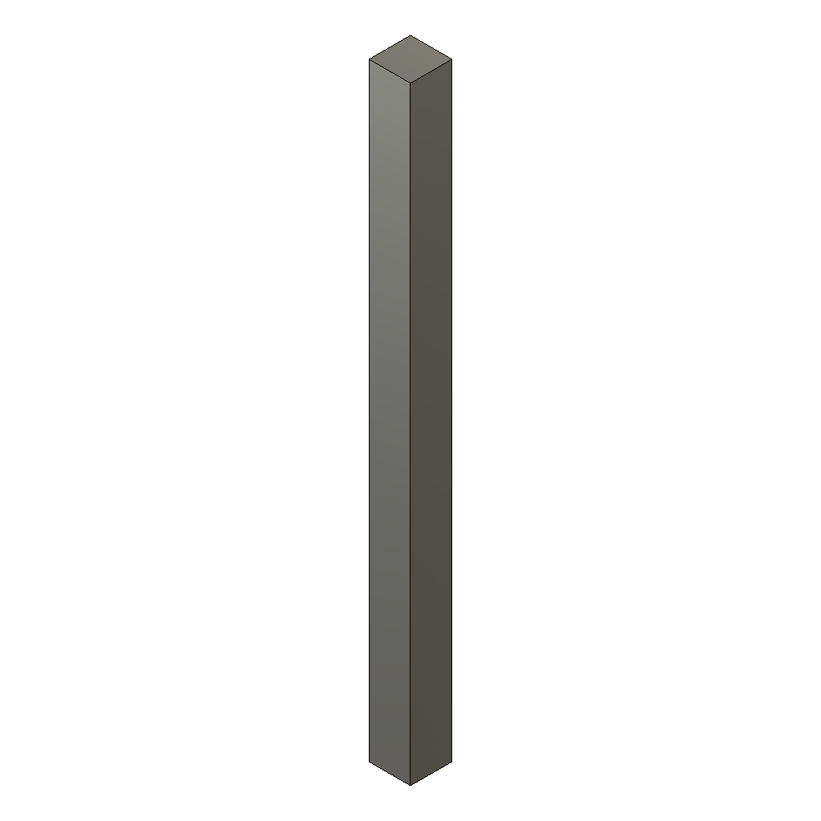  Query design | 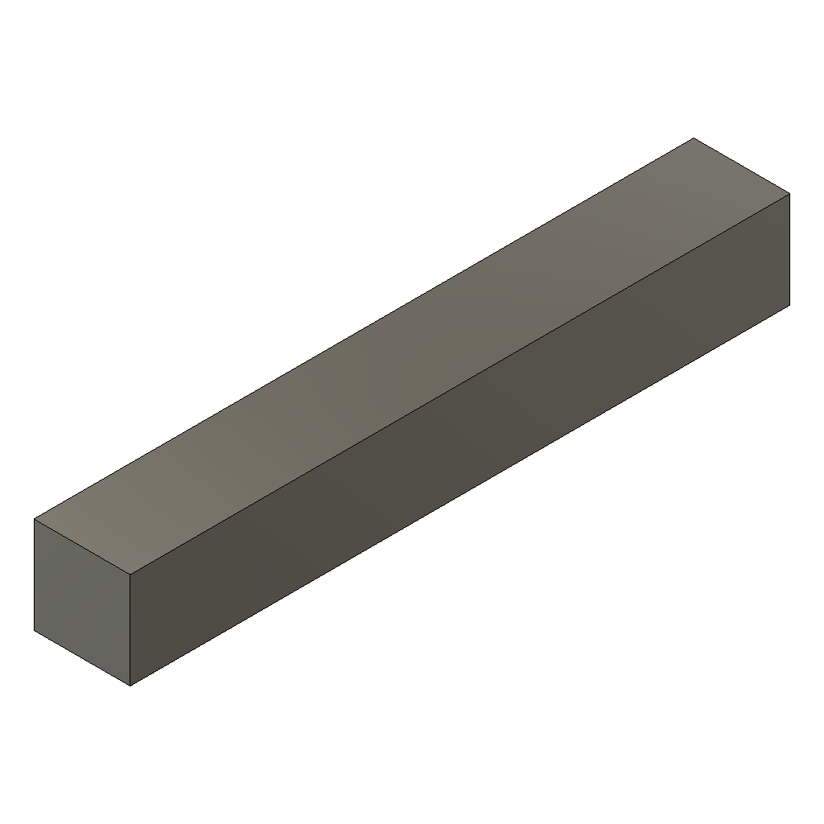  Distance: 0.0397 | 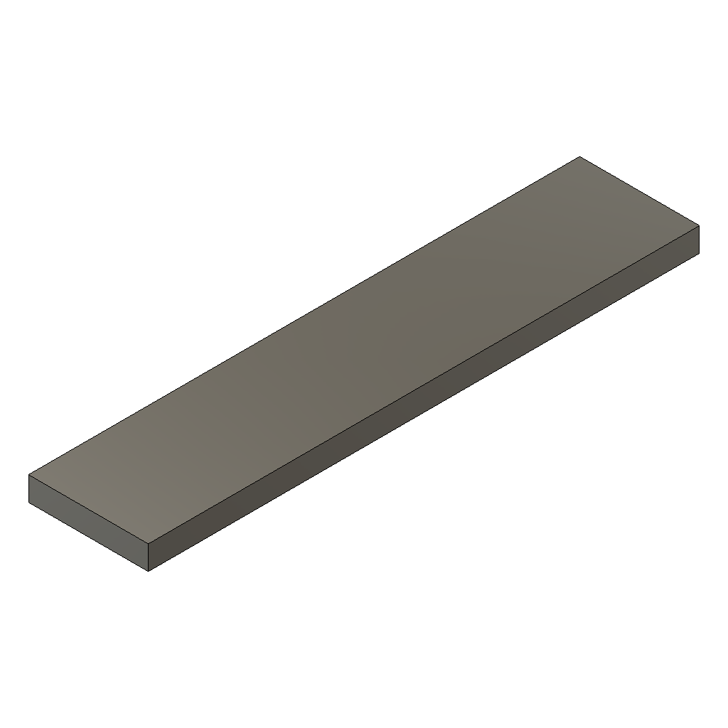  Distance: 0.0630
Example 2:
Query Part | Match 1 | Match 2
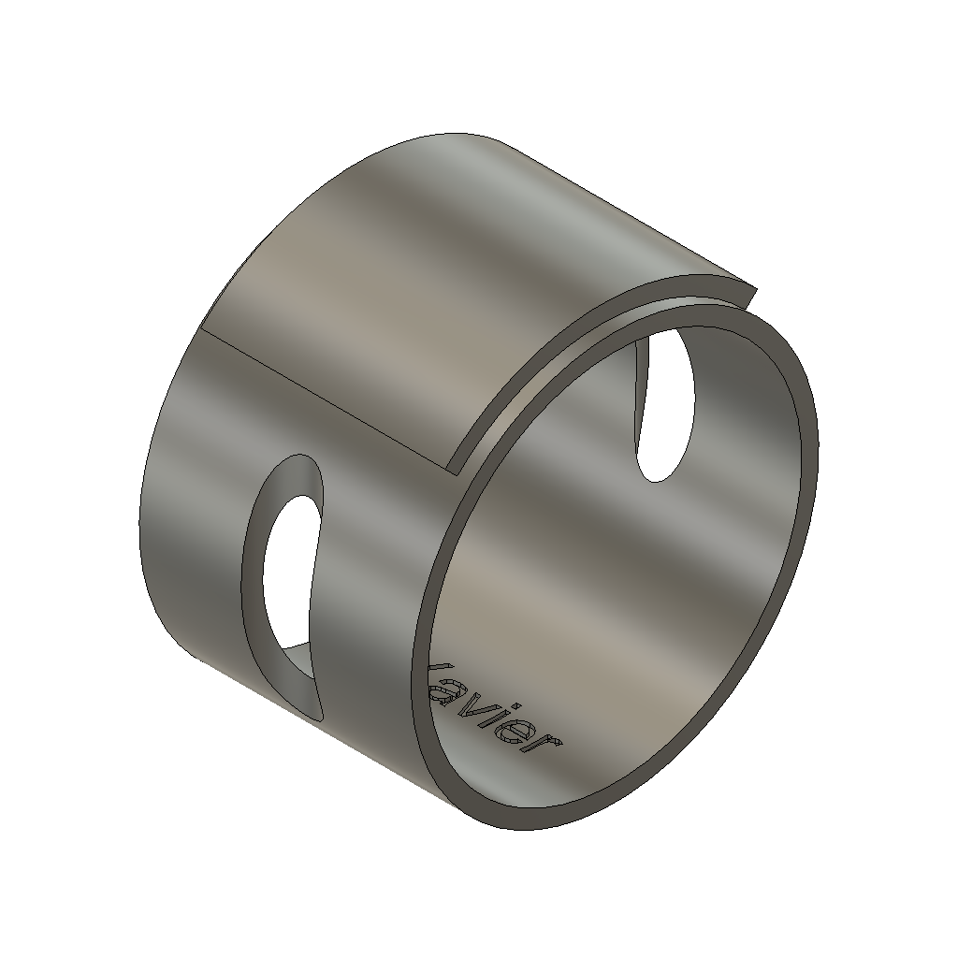  Query design | 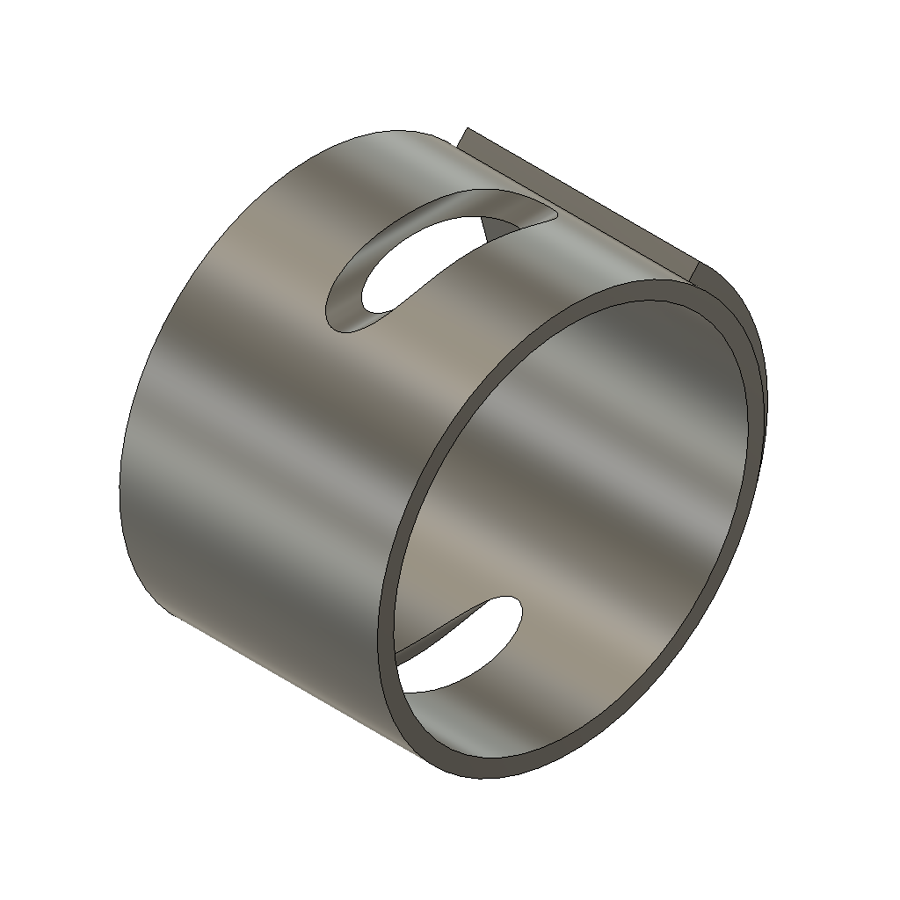  Distance: 0.2280 | 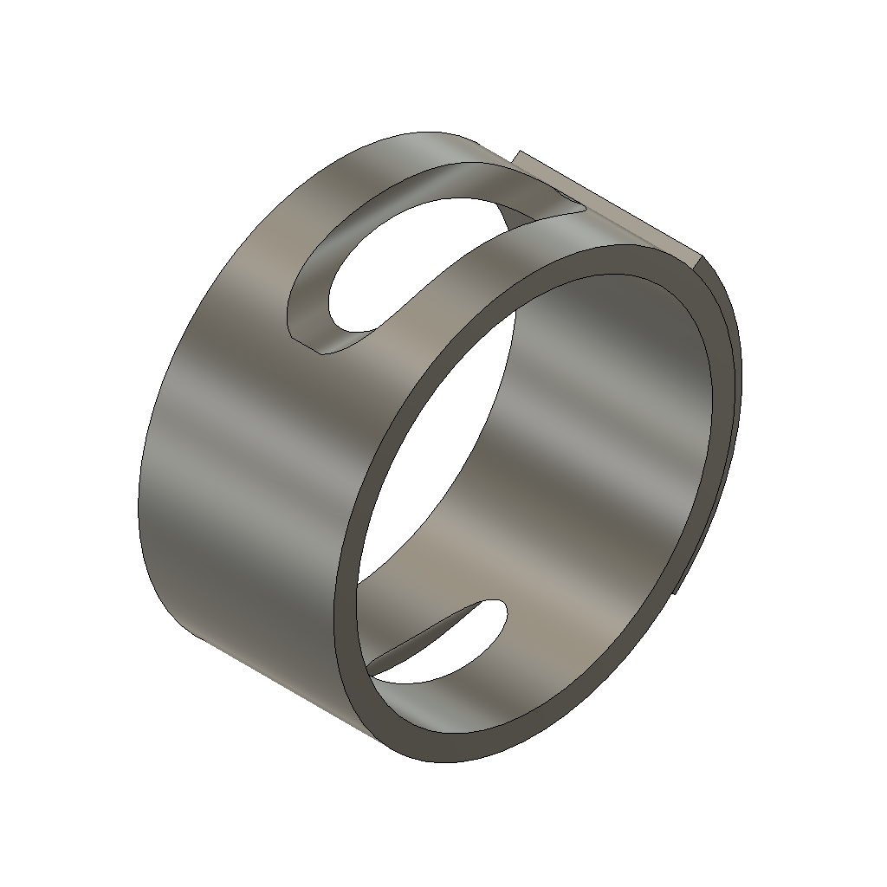  Distance: 0.2484
Example 3:
Query Part | Match 1 | Match 2
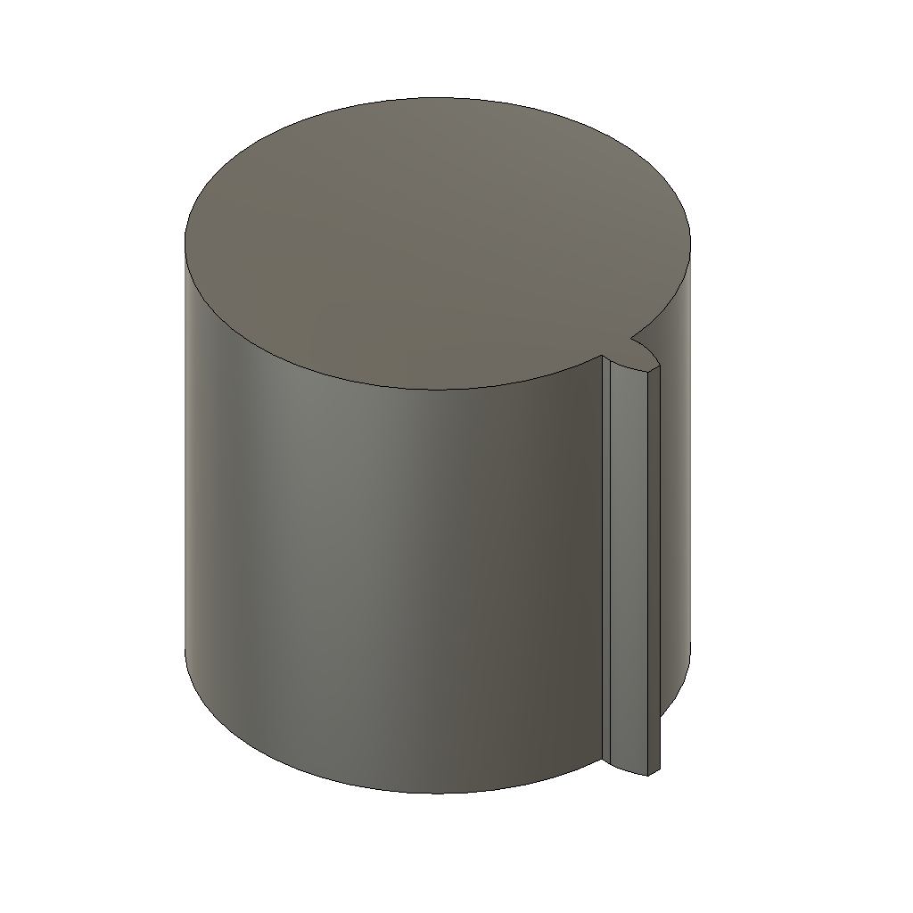  Query design | 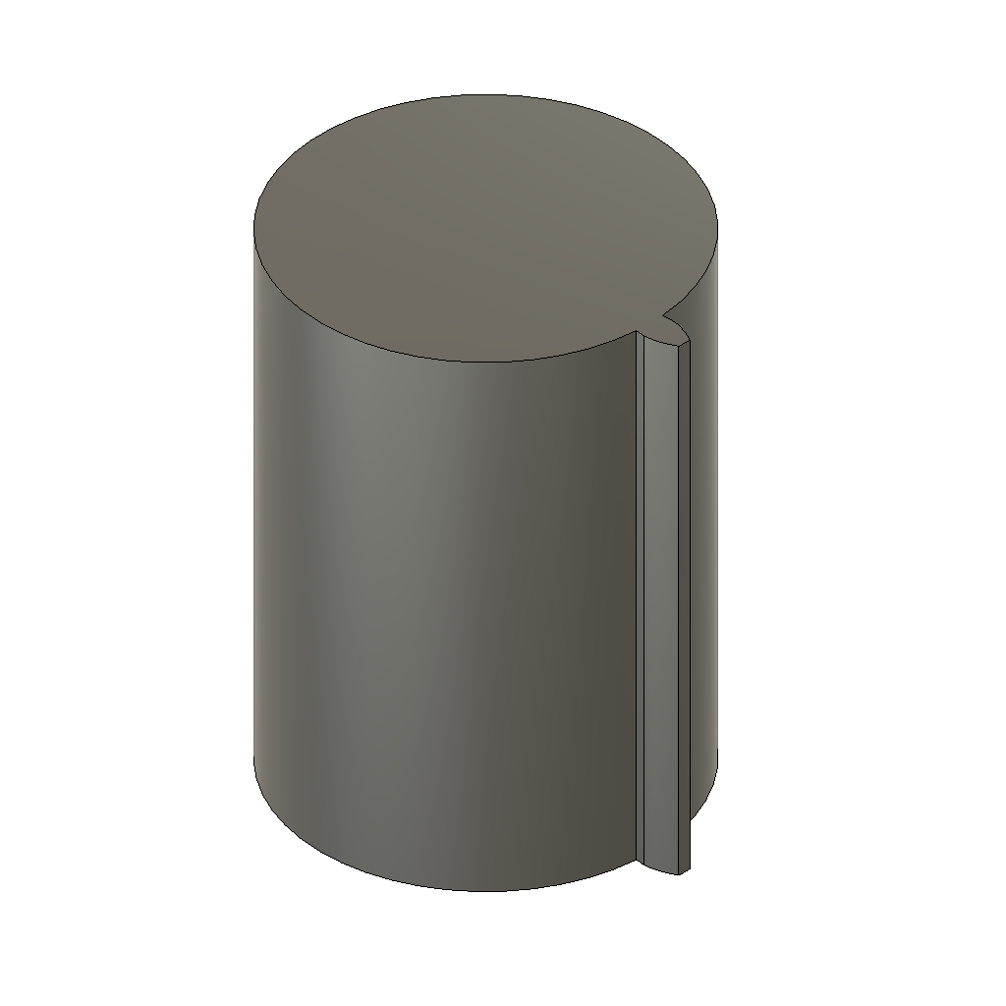  Distance: 0.0333 | 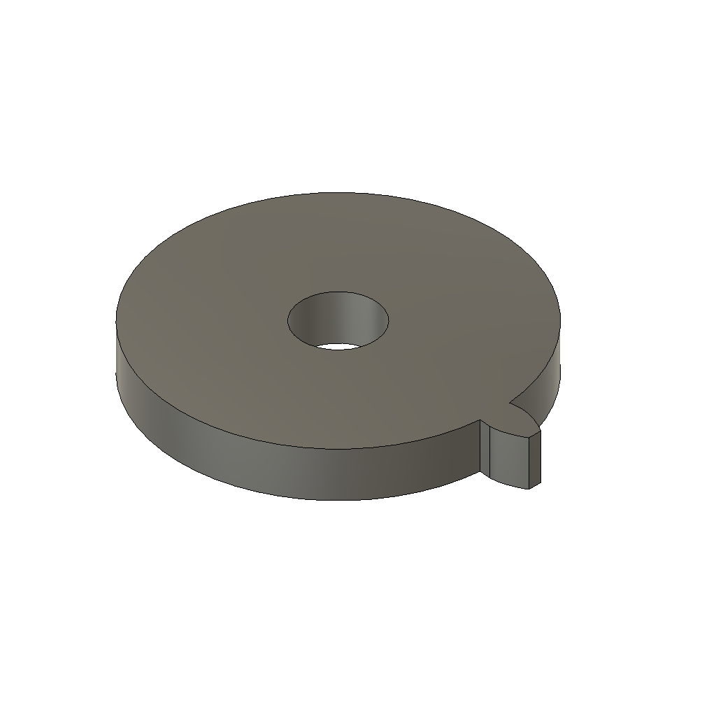  Distance: 0.1201

Value for Engineers
- Lets engineers check for a reusable existing design before starting from scratch, shortening design cycles.
- Searches by actual geometric and structural similarity, not filename, folder location, or tribal knowledge of who worked on something similar.
- Format-agnostic foundation (STEP-based) makes the approach broadly applicable across clients' differing native CAD systems.
- The same technical building blocks extend naturally to adjacent problems, such as automated manufacturability screening, without starting over.

Next Steps
- Broaden validation across a larger and more complex sample of designs to better characterize retrieval quality.
- Build a simple interactive search interface to make the capability tangible in stakeholder discussions.
- Apply the same technical foundation to a second use case: automated manufacturability / feature screening.
- Assess what would be required to adapt this approach to a specific client's CAD data and repository.

